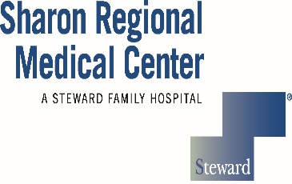
Sharon Regional School of Nursing
740 East State Street, Sharon PA 16146
(724) 983-3865

TRANSCRIPT REQUEST

___________________________________________________________________
Last Name First Name Middle Initial

___________________________________________________________________
Current Address State Zip Code

___________________________________________________________________
Last 4 Digit SSN Previous/Maiden Name (if applicable) Graduation Year

Contact number: ______________________________________________________

- Transcripts are issued in accordance with the Federal “Family Educational Rights and Privacy Act of 1974”.
- Transcripts are $10.00 each.
- Checks should be made payable to: Sharon Regional School of Nursing or pay by phone 724-983-5601.
- Complete the “send to” address section below……….
Send to: __________________________________________________
__________________________________________________
__________________________________________________
-------------------------------------------------------------------------------------------------------------------------------
School of Nursing Administrative Section:
Paid:___________________
Date transcript request received:_______________________________
Date transcript sent:_______________________________

