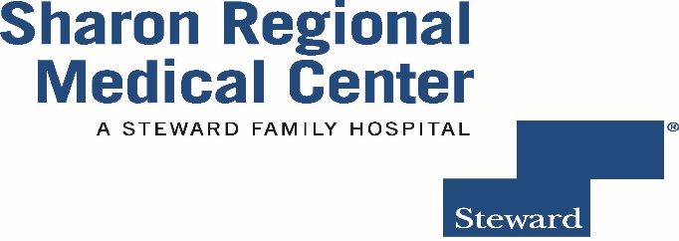
Sharon Regional School of Nursing
Class or 2018

ALUMNI SURVEY

Please respond to the following items and return in the enclosed addressed, stamped envelope to Sharon Regional School of Nursing. You may also choose to complete the survey on the website or e-mail the survey to me at Maryjane.Larmon@Steward.org. The information you provide is used to evaluate your satisfaction with the program as well as your perception of your ability to meet the beginning practitioner competencies. Thank you for your feedback.

- Name:_______________________________ E mail address ___________________

2. Home address: ________________________________ Telephone #_____________________

3. Please rate you level of comfort with the following Nursing Graduate Outcomes utilizing the following Likert Scale: (refer to the Nursing Graduate Outcomes attached for definitions)

- Very Dissatisfied (2) Dissatisfied (3) Satisfied (4) Very Satisfied

- Safety and Quality
I am able to demonstrate professional knowledge, skills, and attitudes in patient safety and quality initiatives.
1 2 3 4
Comments: ___________________________________________________________________

_______________________________________________________________________________

- Teamwork and Collaboration:
I am able to collaborate with nursing and interdisciplinary team members to provide safe, competent care for meeting optimal patient outcomes.

1 2 3 4
Comments: ___________________________________________________________________

_______________________________________________________________________________

3. Evidence Based Practice:
I am able to demonstrate the use of best current evidence in nursing judgment for safe quality care.

1 2 3 4

Comments: _____________________________________________________________________

______________________________________________________________________________

- Patient Centered Care:
I am able to respect the patient and the family as the center of the health care team.
1 2 3 4
Comments: _____________________________________________________________________

_______________________________________________________________________________

- Informatics Technology:
I am able to utilize technology as appropriate to apply evidence for nursing practice and patient safety.
1 2 3 4
Comments: _____________________________________________________________________

_______________________________________________________________________________

- Professional Identity:
I am able to demonstrate professional integrity and accountability within established legal standards and ethical principles.
1 2 3 4
Comments: _____________________________________________________________________

_______________________________________________________________________________

Overall Satisfaction with the SON 1 2 3 4

Comments: _____________________________________________________________________

______________________________________________________________________________

_______________________________________

4. Are you currently employed as an RN? Yes No (please circle one)

5. Where do you currently work? _________________________________________________

Thank you for your time and input!
Mary Jane Larmon, MBA, MSN, RN
Director, Sharon Regional School of Nursing

